Instructions for Preparing a Paper for PFDM Conference 2025
Firstname A. Lastname¹, Firstname B. Lastname², and Firstname C. Lastname^{3*}
Abstract: The abstract must fit on this title page and within the box, and should not include figures, tables, or citations. The abstract text should be written in Times New Roman, 10 pt and the total word count should be between 200 to 300 words, in no case exceeding 300 words. The primary paper contents should start immediately below the abstract.
Keywords: A maximum of four keywords must be added separated by a colon.

- Introduction
Authors are requested to revise their manuscript based on the comments provided by the reviewers and must not exceed 4 pages, including references and figures. The paper must be an original work that has not been published or submitted, in whole or in part, to any other conference, journal, or book. Authors are responsible for ensuring the novelty of the content and confirming that the manuscript does not contain material under consideration elsewhere. The paper must be written in English language following United Kingdom spelling and grammar conventions throughout the manuscript. Add the title in place of the line ‘Instructions for Preparing a Paper for PFDM Conference 2025’ using title case in Times New Roman font and 18 pt size. Please add the names, affiliations, and e-mail addresses of the authors to the header and footer by replacing the highlighted text with your details and remove the yellow highlighting after replacement. Use only the first initial of any middle name(s), followed by a period as shown in the author line. Do not edit any other parts of the headers or footers. The footer on the first and second page both have to be edited individually. The paper size is European A4 (21 x 29.7 cm). The left and right margins are 1.27 cm, the top margin (not including the header) is 2.5 cm, and the bottom margin is 1.9 cm.
The first line of each paragraph should begin immediately below the section heading, aligned with the left margin. All subsequent lines in the paragraph should have a first-line indent of 0.6 cm. There should be no additional spacing between consecutive paragraphs. The author’s name or authors’ names should be in Times New Roman, 10 pt in the header, while the affiliation should be in 7 pt in the footer. First-level headings (e.g., 1. Introduction, 2. Methodology) should be in Times New Roman, 11 pt font, bold. A spacing of 6 pt should be added before second- and third-level headings. All the headings and corresponding sub-headings must be numbered and should not exceed third-level heading. Please upload your finished manuscript as .docx. file; PDFs will not be accepted.
- Materials and methods (second-level heading)
The second-level heading should be in Times New Roman, 11-point font, regular (not bold).
- Sample preparation (third-level heading)
The third-level headings should be in Times New Roman, 11-point font, italics.
- Equations, Figures, and Tables
Equations should be numbered continuously according to the format shown in Equation (1):
$$e^{iπ}+1=0$$ | (1)
where the unknown symbols are explained after the equation.
Figures, graphs and tables must be included using the same style as in Figure 1 and Table 1. Both figures and tables should be centered on the page. Use of at least 300 dpi resolution for pictures and line art is required, 1 px wide lines in figures should be avoided as they may become invisible in print. For the captions in Figures and Tables, the authors must use Times New Roman, 10 pt font.
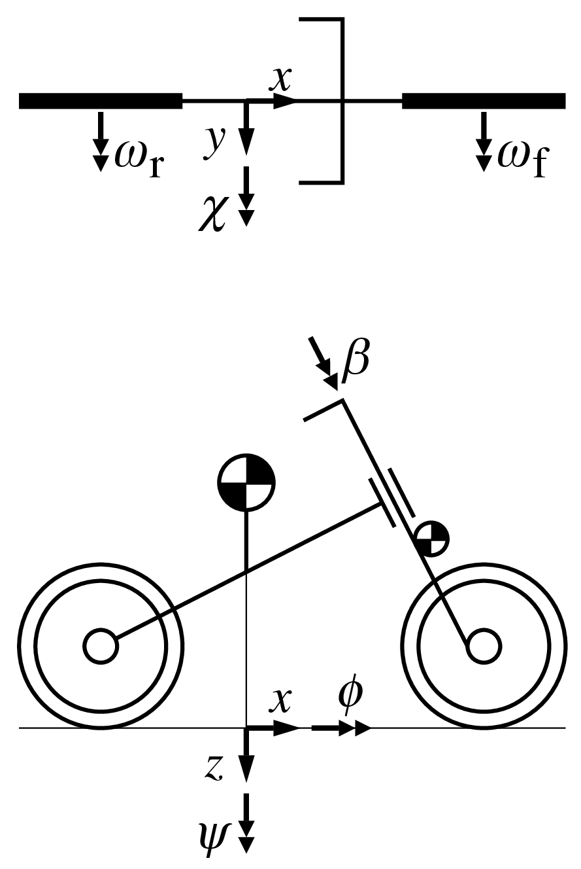
Figure 1. An example of a figure caption. Use 10 pt Times New Roman. Use the same style for the tables.
Check the copyright of the uploaded images!
Table 1. Example of a table with a short caption.
 | x | y | z
x' | α₁ | β₁ | γ₁
y' | α₂ | β₂ | γ₂
z' | α₃ | β₃ | γ₃
- Bibliography
Bibliographical citations should be written in alphabetical order in the References section at the end of the document and use the ASCE citation system and format. See the References section below, exemplifying the cases of a journal, textbook or thesis or report, a webpage or software, and an article in a conference proceeding. Use author–year style for all in-text citations. For example:
- Single author: (Smith, 2020)
- Two authors: (Smith and Jones, 2021)
- Three or more authors: (Smith et al., 2022)
- Conclusion
We very much look forward to welcoming you to Delft! Best wishes and the warmest regards from the Organizing Committee of PFDM 2025.

References

The references section as well as the references should not be numbered. The authors must use the reference format below with no spacing between two consecutive references.
Author Surname, Initial., and Author Surname, Initial. (Year of Publication). “Title of Article.” Title of Journal, Volume (issue number), pages.
Author Surname, Initial., and Author Surname, Initial. (Year of publication). Title of Text, Publisher, City/State Published.
Author Surname, Initial., and Author Surname, Initial. (Year of publication). Name of webpage or software, <URL> (accessed date).
Author Surname, Initial., and Author Surname, Initial. (Year of Publication). “Name of paper.” Name of Conference, Name of publisher, Publisher location, page range of paper.

